**UNIVERSITY OF SCIENCE AND TECHNOLOGY OF SOUTHERN PHILIPPINES**

**VILLANUEVA CAMPUS**

**Name: Lacadin, Sherwin Dave M.  
Section & Year: BSIT 3B  
Date:9/28/2024**

**Code** 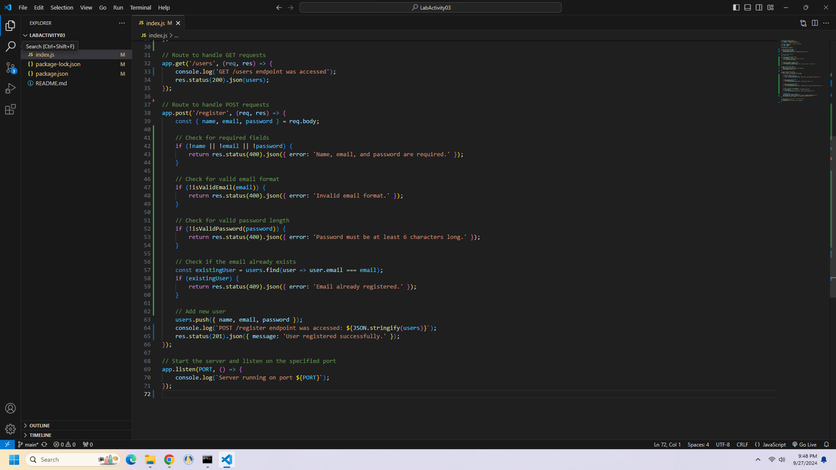

**Terminal**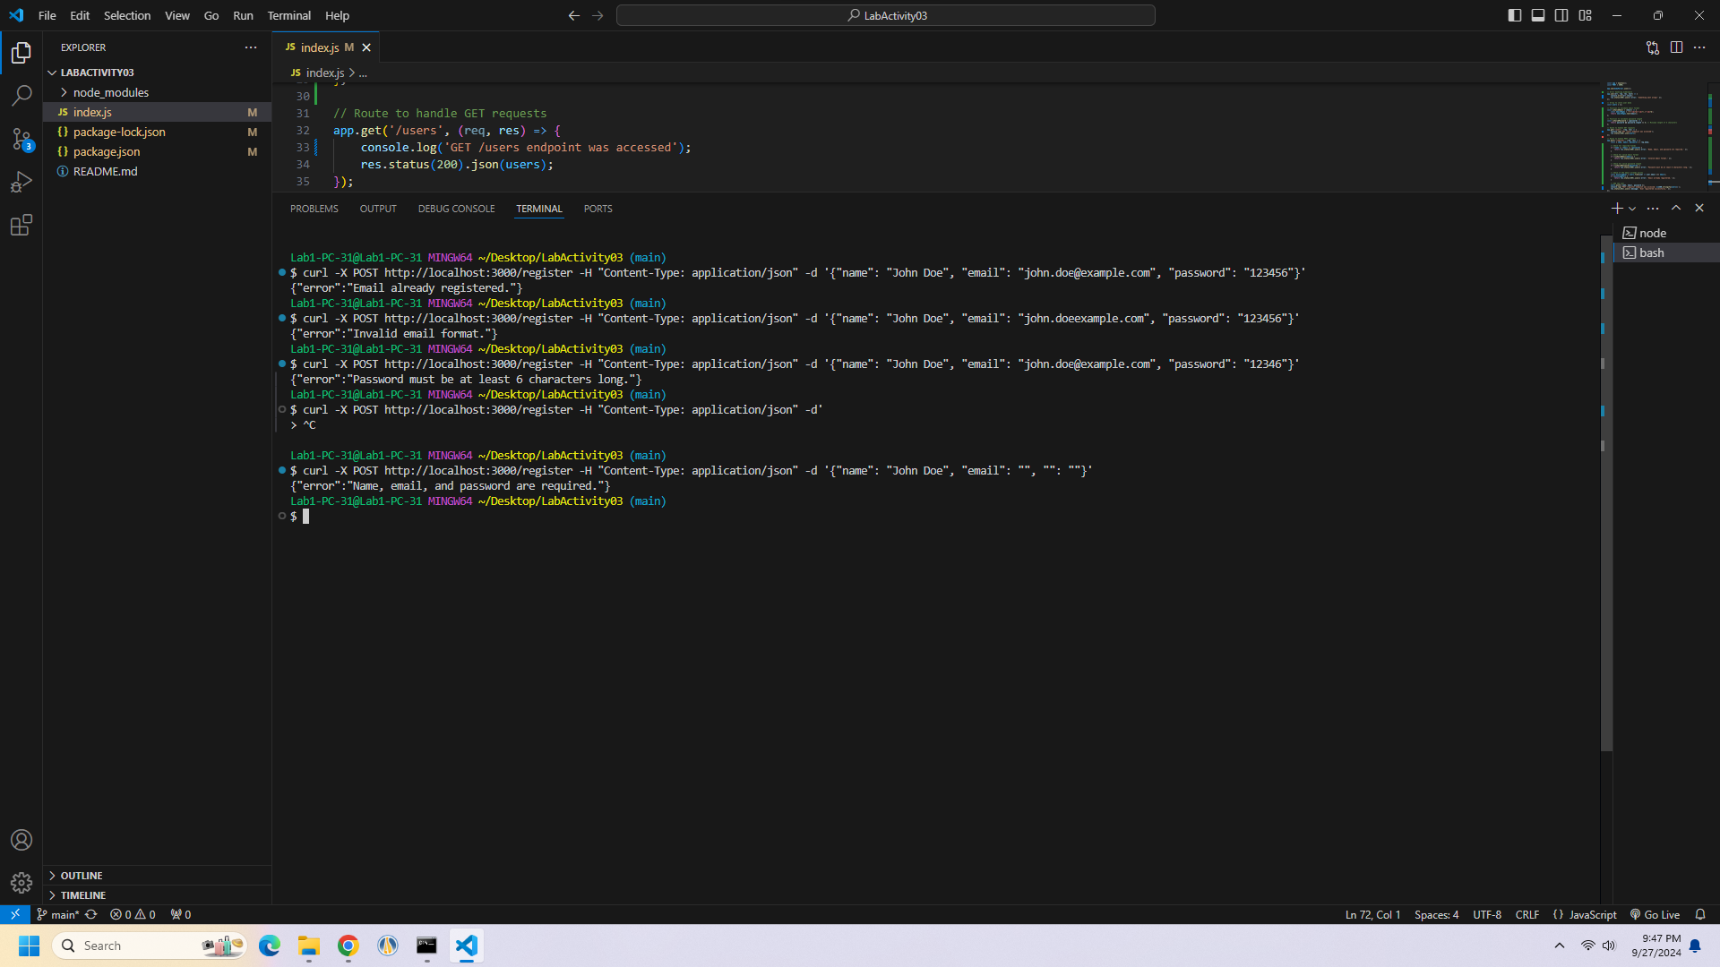

**Local Host**